**Alberta**

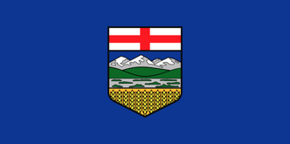

### **211 Alberta**

Call 2-1-1 or text INFO to 2-1-1.

* Available 24 hours a day, 7 days a week
* Crisis support and virtual services
* Connect to local mental health and addiction services

### **Alberta Mental Health Line**

Call 1-877-303-2642 (toll-free).

* Available 24 hours a day, 7 days a week
* Confidential support, information and referrals
* Staffed by mental health professionals

**AHS EMS Provincial Chaplaincy Team (Internal Program for AHS EMS Employees) and**

**AHS EMS Provincial Peer Support Program (Internal Program for AHS EMS Employees)**

Website: <https://www.albertahealthservices.ca/default.aspx>

Email: [EMSPeerSupport.Admin@albertahealthservices.ca](mailto:EMSPeerSupport.Admin@albertahealthservices.ca)

**British Columbia**

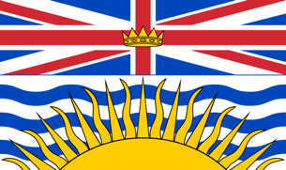

**BC First Responders' Mental Health** <https://bcfirstrespondersmentalhealth.com/>

**Work Safe BC Crisis Support Line:**

* + - * **Phone:** 1-800-624-2928
      * **Availability:** 24 hours a day, 7 days a week
      * **For:** Injured workers and their families in emotional crisis

**310 Mental Health Support:**

* + - * **Phone:** 310-6789 (no area code needed)
      * **Availability:** 24 hours a day



* Critical Incident Stress Management (CISM) 1-855-969-4321. A dedicated peer group that supports wellness by providing education, resources and CISM interventions.
* Homewood Health Solutions (EFAP) 1-800-663-1142. Your employee and family assistance program.

**Manitoba**

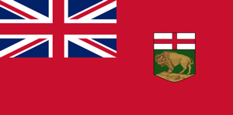

<https://www.gov.mb.ca/mhcw/>

**Call 2-1-1**

* Available 24 hours a day, 7 days a week
* Crisis support and virtual services
* Connect to local mental health and addiction services

**Klinic Crisis Line**  
 [204-786-8686](tel:12047868686) [1-877-435-7170 (toll free)](tel:18774357170)

**Project Resilience 911** – English only

Website <http://facebook.com/groups/706005539891590>

Email: [Projectresilience911@gmail.com](mailto:Projectresilience911@gmail.com)

**Northwest Territories**

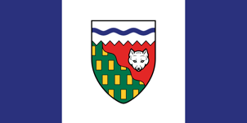

**988** **Suicide Crisis Helpline**. A safe space to talk, 24 hours a day, every day of the year.

**811 Helpline** responders are registered nurses who can also assist you with concerns related to mental wellness and addictions recovery. Our nurses are trained in a variety of areas, including stress management, suicidal thoughts, abuse, sexual assault, depression, anxiety, grief, loss, and substance use. **Call us at 811 or 1-844-259-1793**. Our services are available in English and French, with translation services provided for all official languages of the NWT. Your comfort is important, which is why this service remains 100% free and confidential.  
  
For more information visit: [www.gov.nt.ca/81](https://www.gov.nt.ca/81)

**Nunavut**



**Nunavut Kamatsiaqtut Help Line** offers anonymous and confidential telephone support 24 hours a day, seven days a week.

* Toll Free 1-800-265-3333
* In Iqaluit 979-3333

**Healing by Talking Program -** a free telephone counselling service provided by the GN’s Department of Health.

* Call 1-888-648-0070
* Email [healing@gov.nu.ca](http://healing@gov.nu.ca/)

**Saskatchewan**

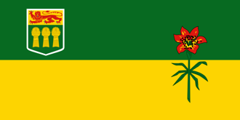

Call Health Line on **811** for professional health or mental health and addictions advice, education and support.

* Open 24/7
* Confidential
* Free
* Translation in over 100 languages

Health Line 811 is a confidential, 24-hour health and mental health and addictions advice, education and support telephone line available to the people of Saskatchewan. It is staffed by experienced and specially trained Registered Nurses, Registered Psychiatric Nurses, and Registered Social Workers.

If you are having technical issues with accessing Health Line 811 by dialing 811, you can call 1-877-800-0002 to be connected with Health Line 811.

Deaf and hard of hearing residents can access Health Line 811 by using the SaskTel Relay Operator service at 1‑800‑855‑0511.

**Yukon**

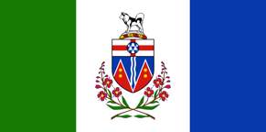

**Government of Yukon: Mental Wellness and Substance Use Services**

Call 867-456-3838 or 1-866-456-3838 (toll free).

* Phone line available Monday to Friday from 8:30 am to 4:30 pm (English and French)
* [Territorial website](https://yukon.ca/en/places/mental-wellness-and-substance-use-services) with information on mental health and substance use supports and services